PREDICTION OF HEALTH INSURANCE PREMIUM COSTS WITH IBM

AUTO AI SERVICE

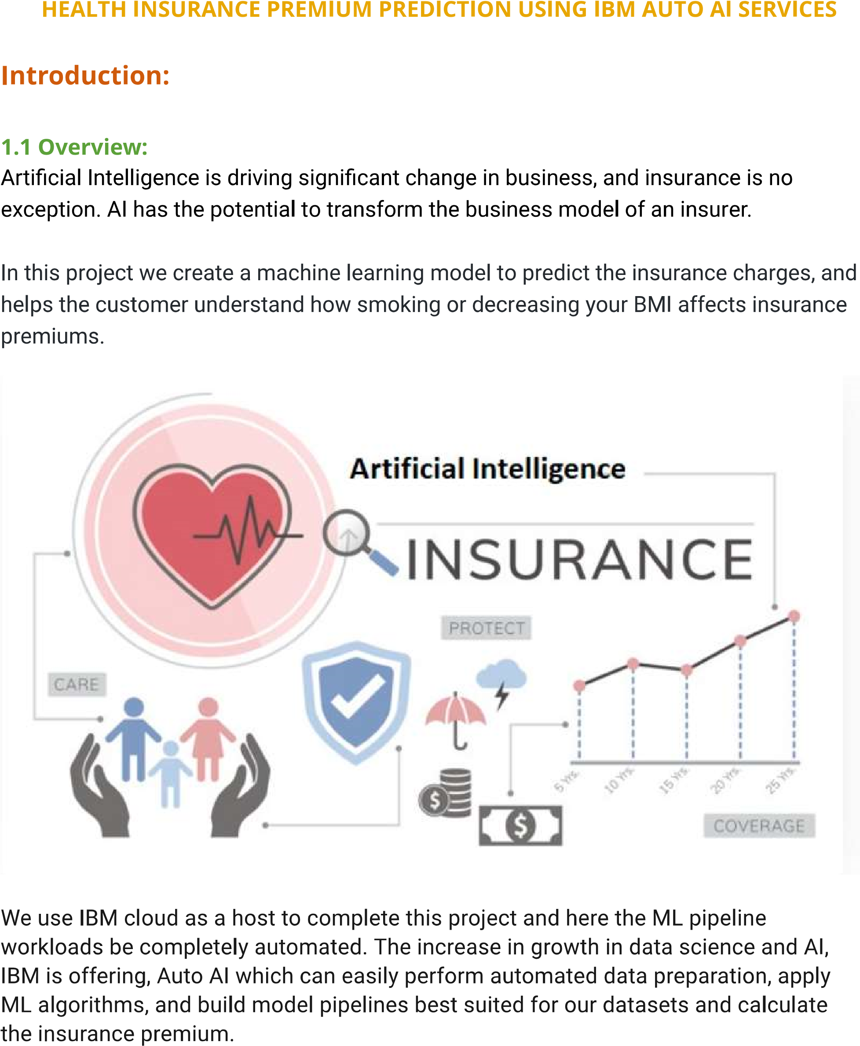

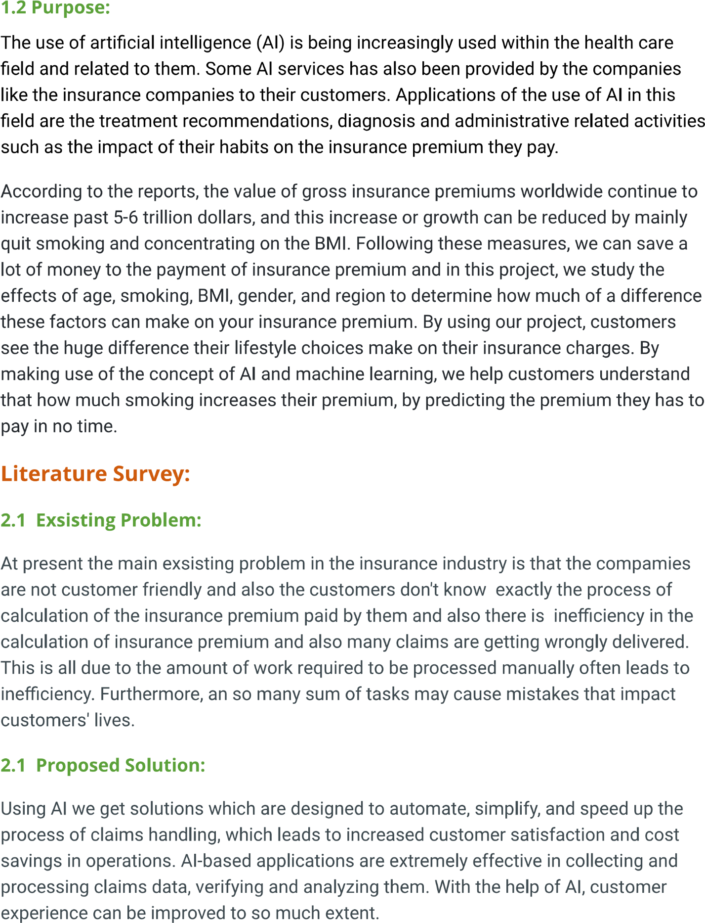

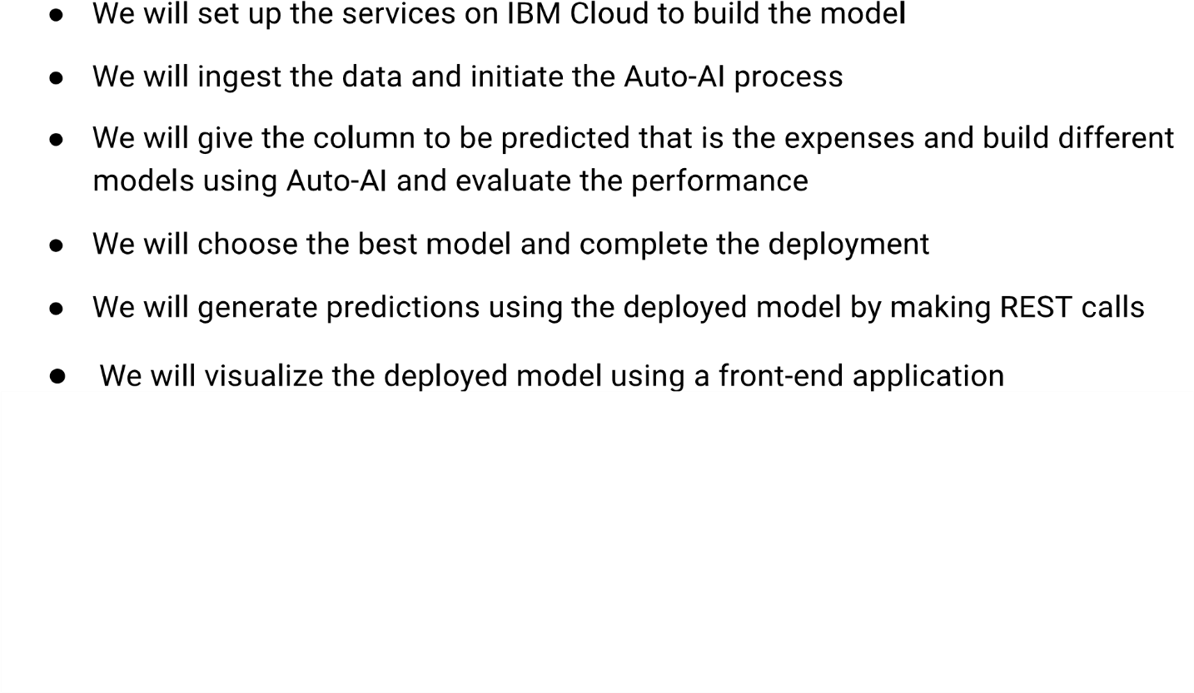

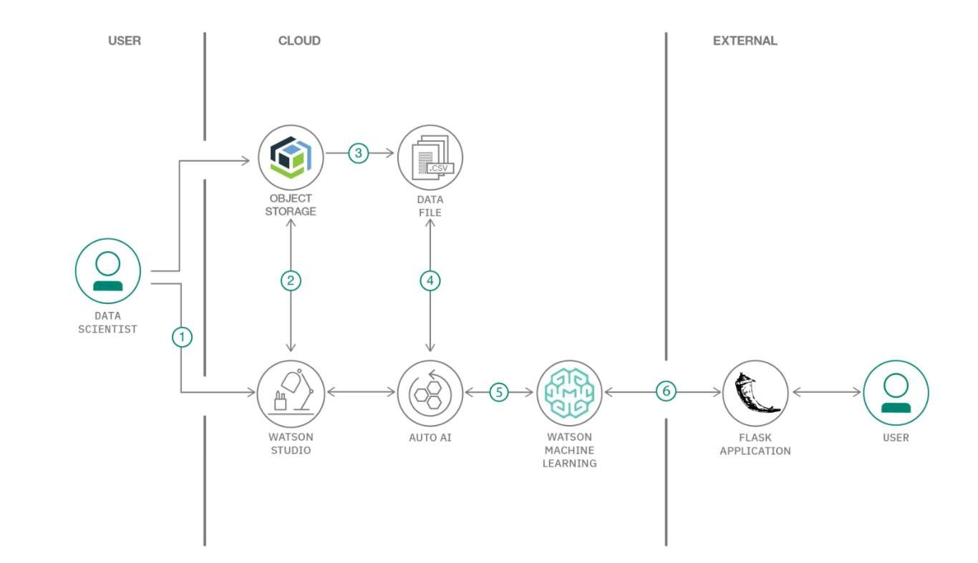



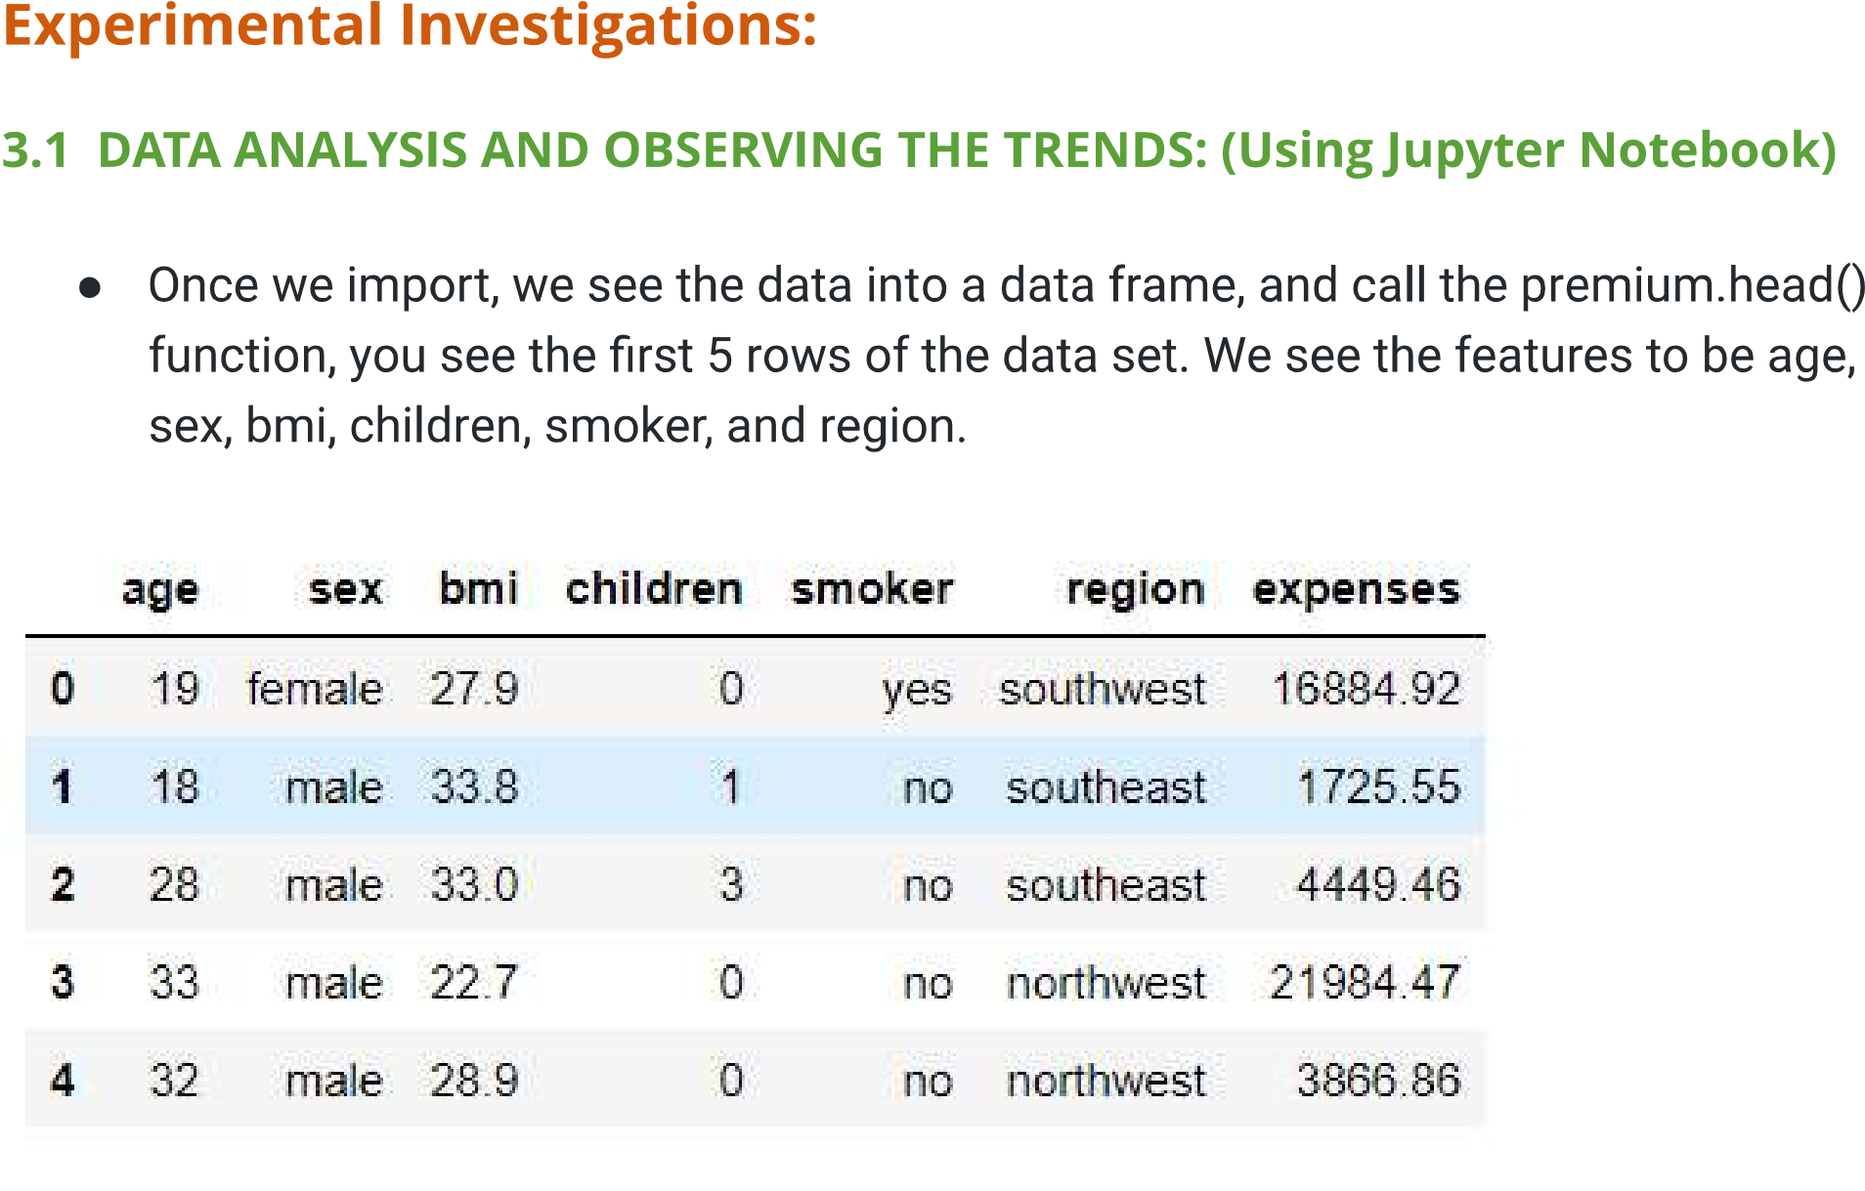

**EXPERIMENTAL INVESTIGATIONS:**

**DATA ANALYSIS (Using Spyder)**

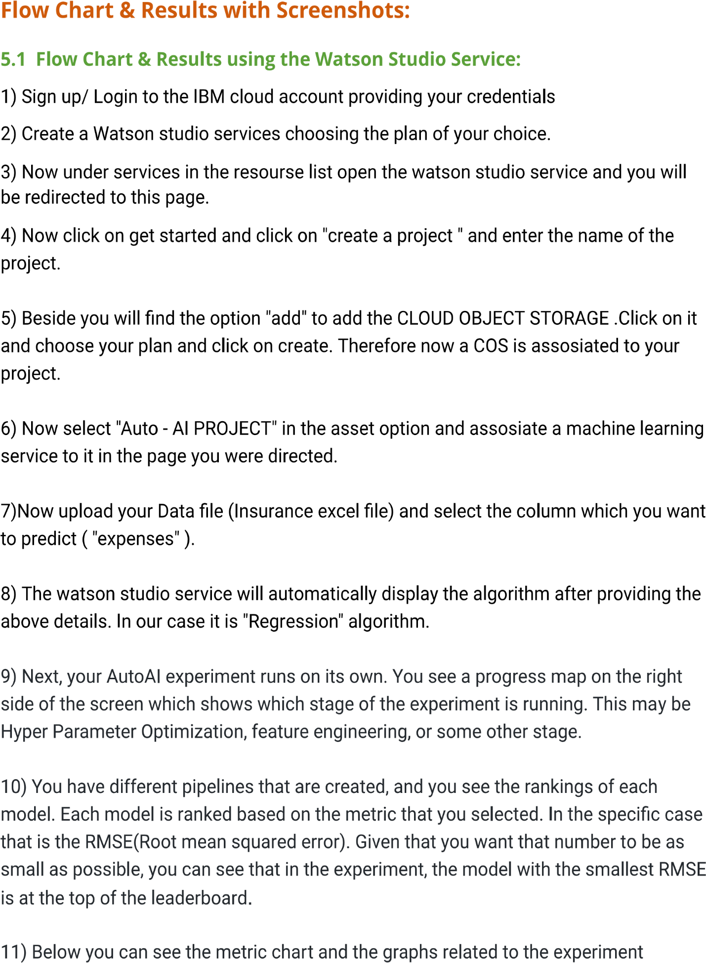

**Flow Chart & Results with Screenshots:**

**Flow chart &results using the Watson studio service:**

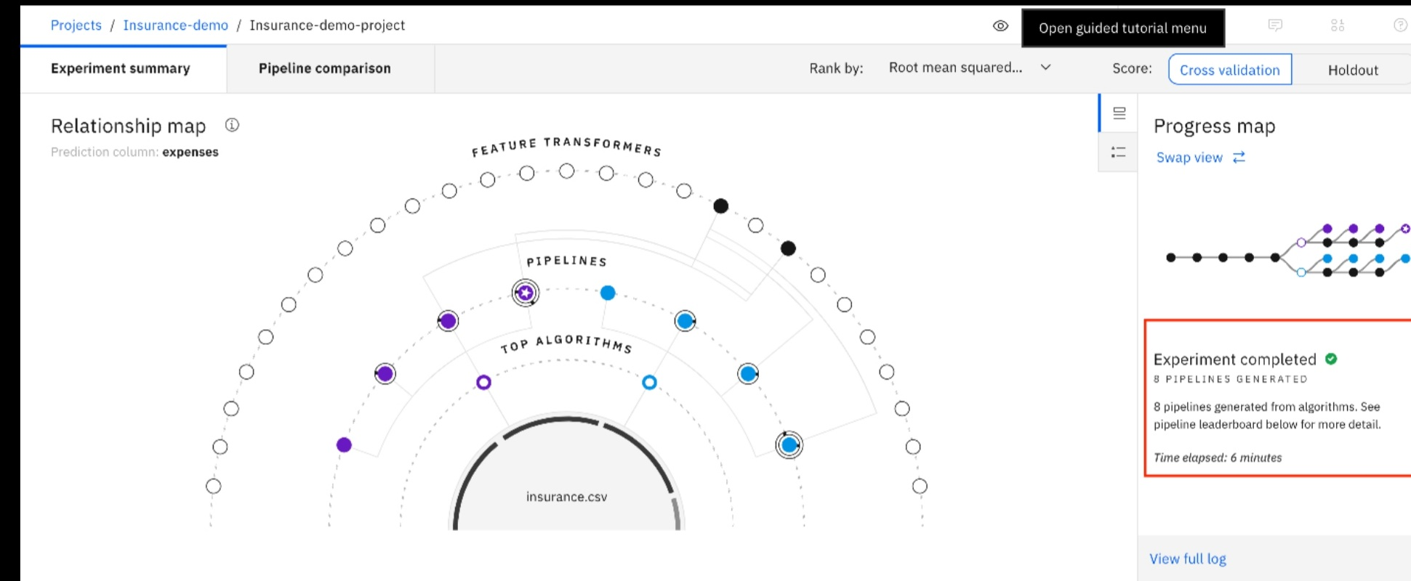

**SCREENSHOTS**:

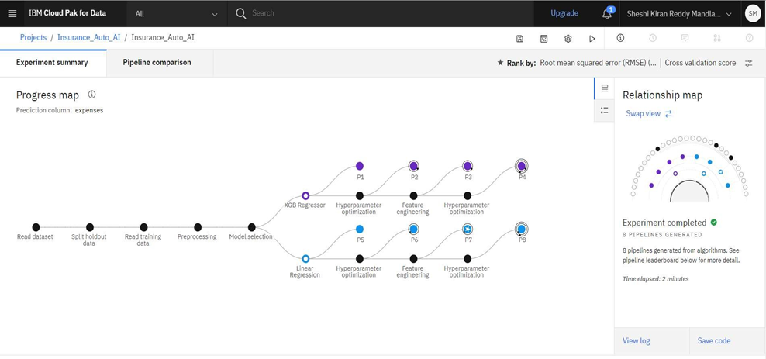

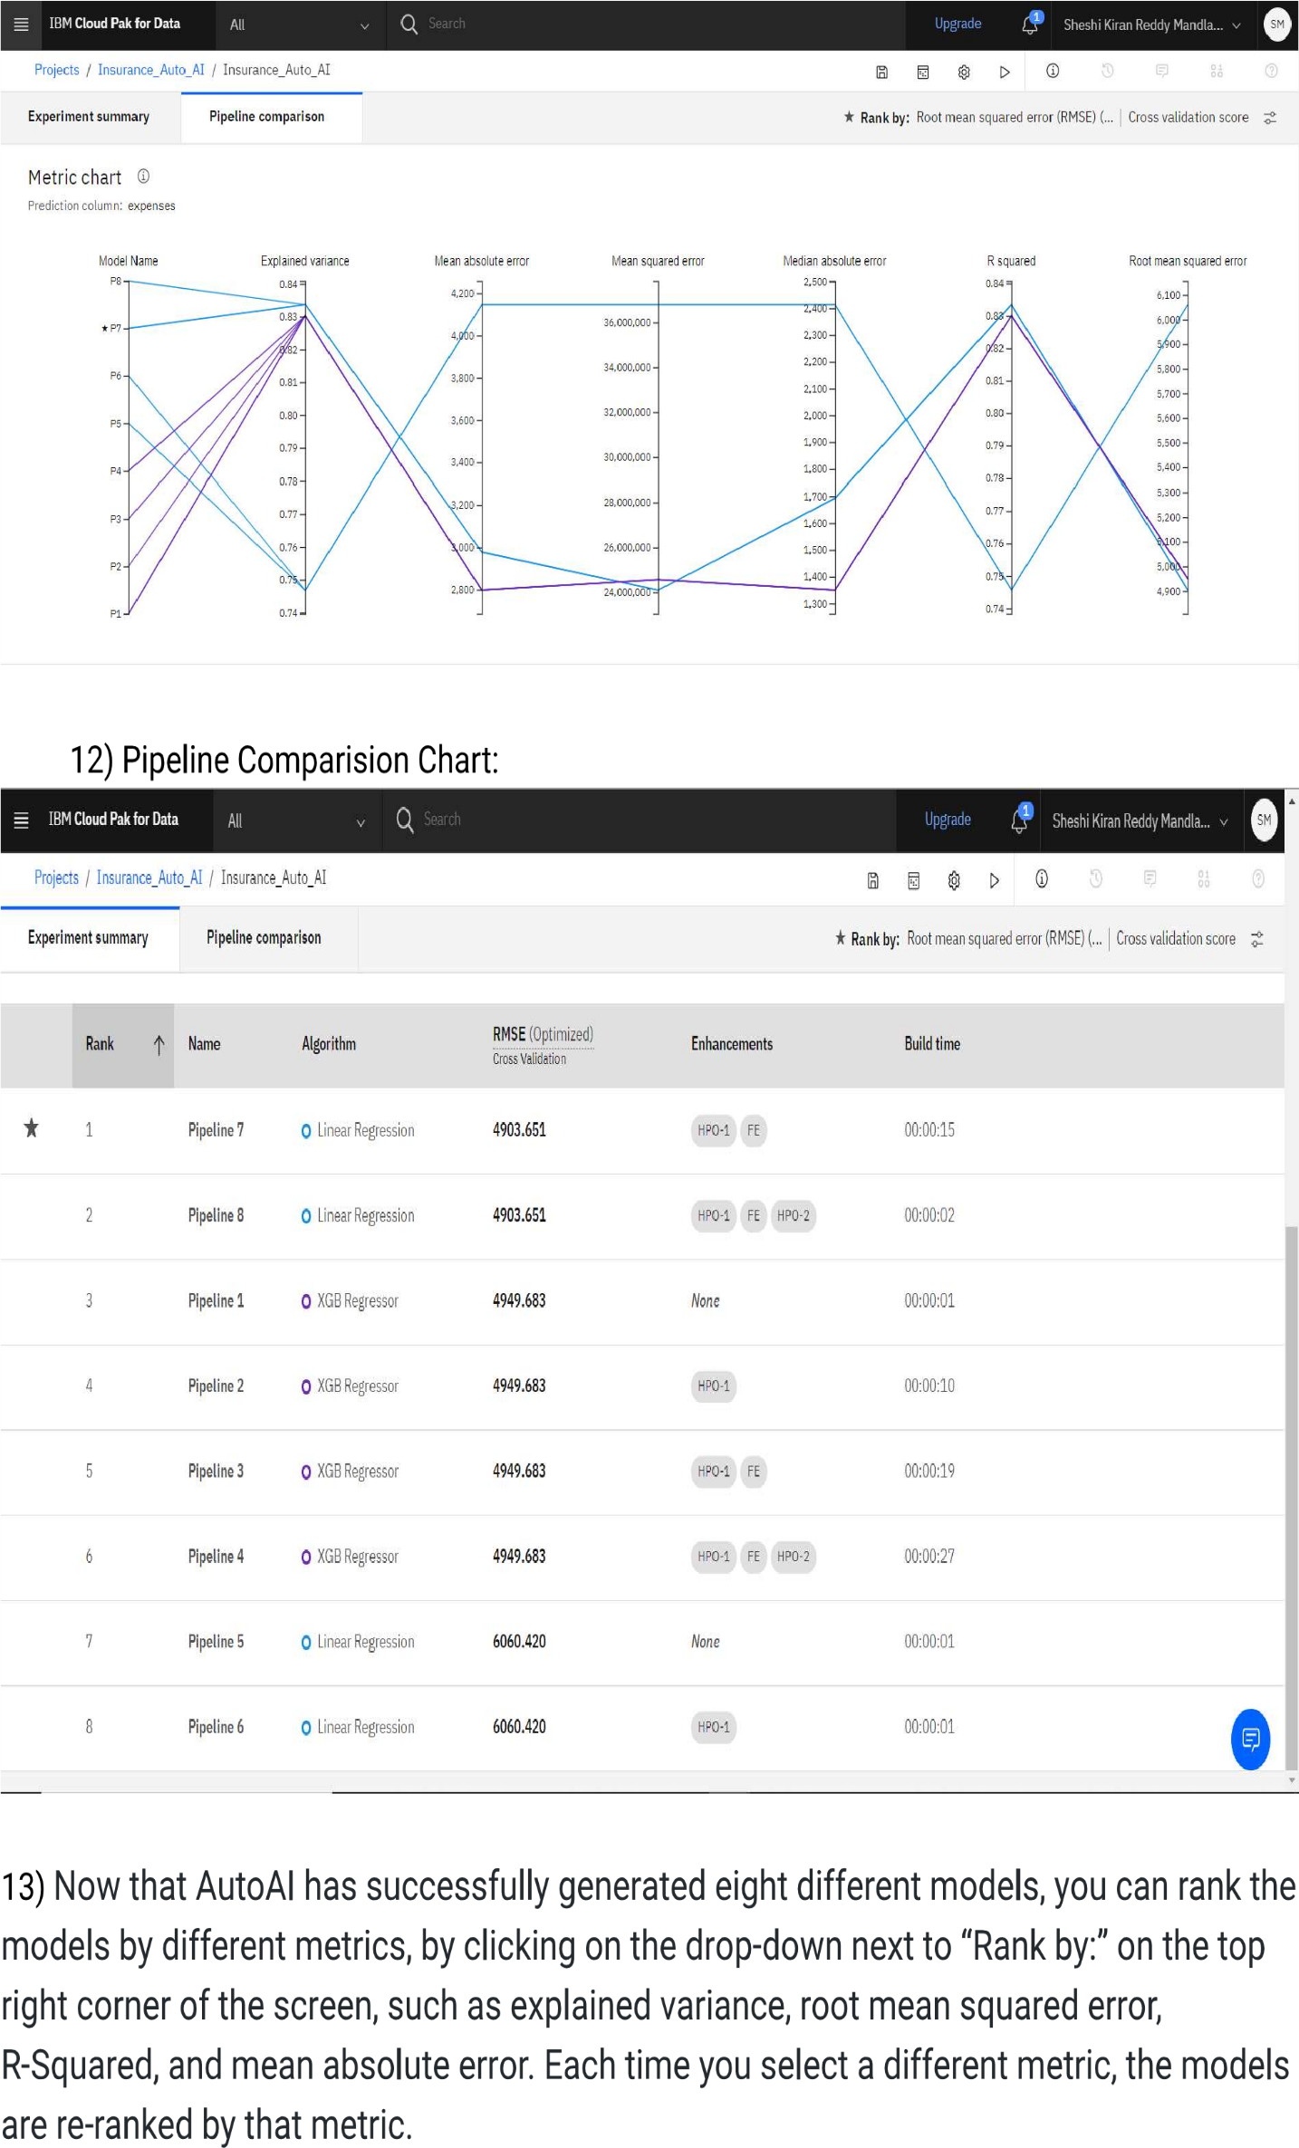

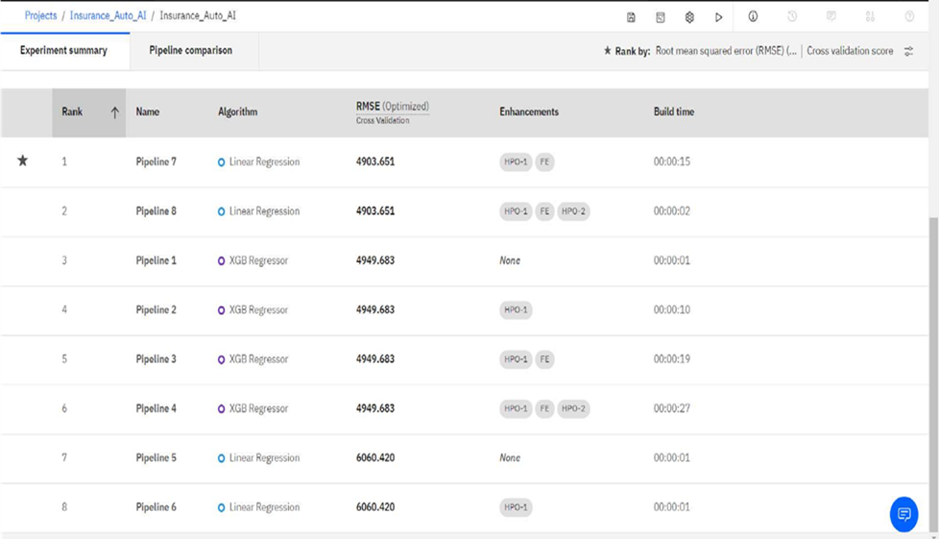

**12)Pipeline Comparison Chart**:

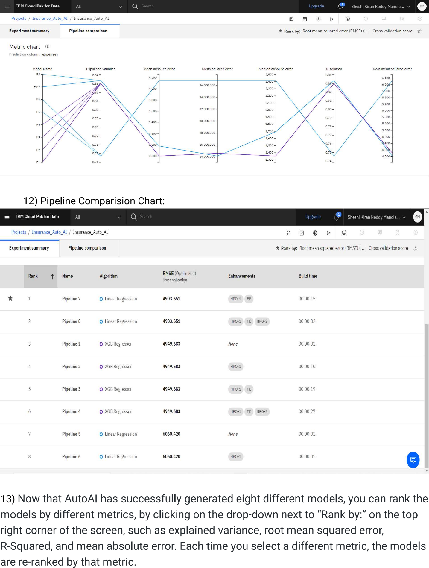

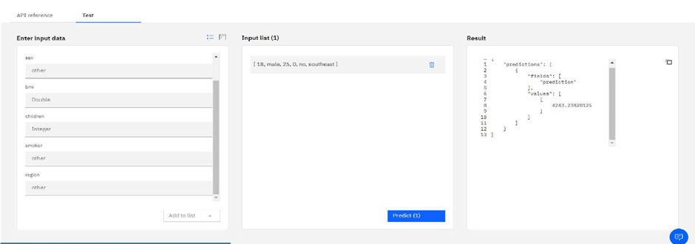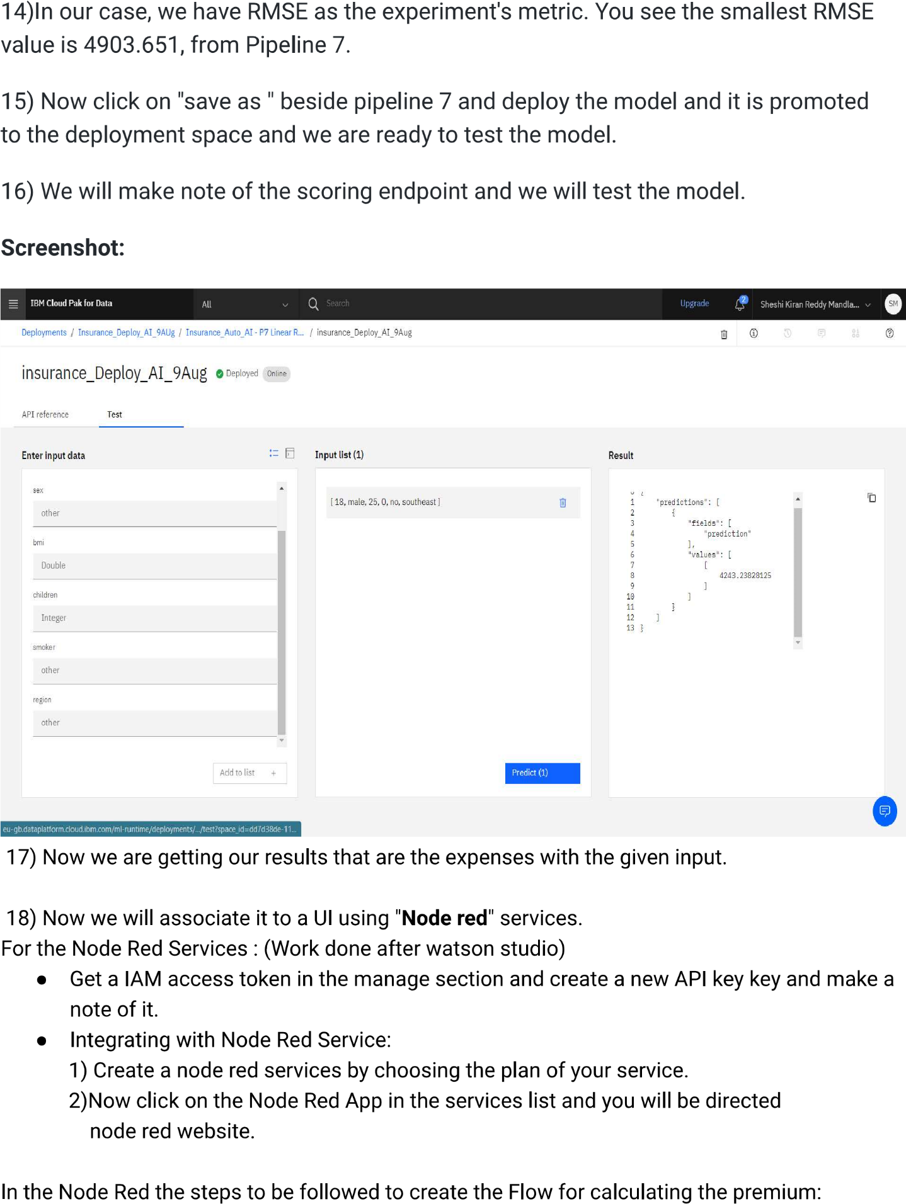

**SCREENSHOT**:

17)Now we are getting our results that are the expenses with the given input.

18)Now we will associate it to a UI using flask application

* Get a IAM access token in the manage section and create a new API key and make a note of it.

Steps to be followed to create the flow for calculating the premium:

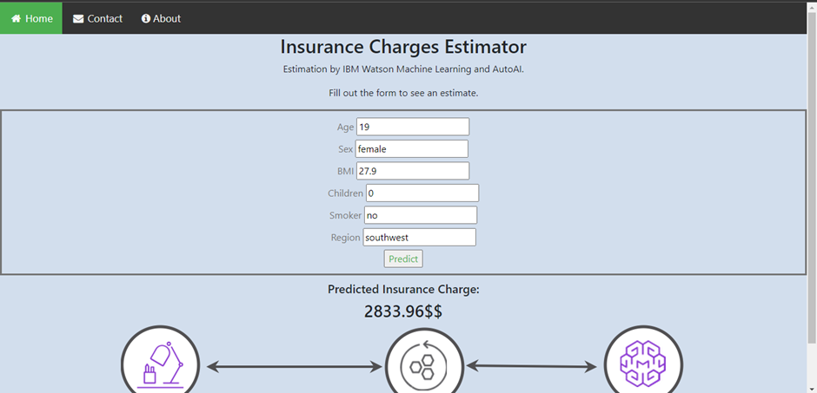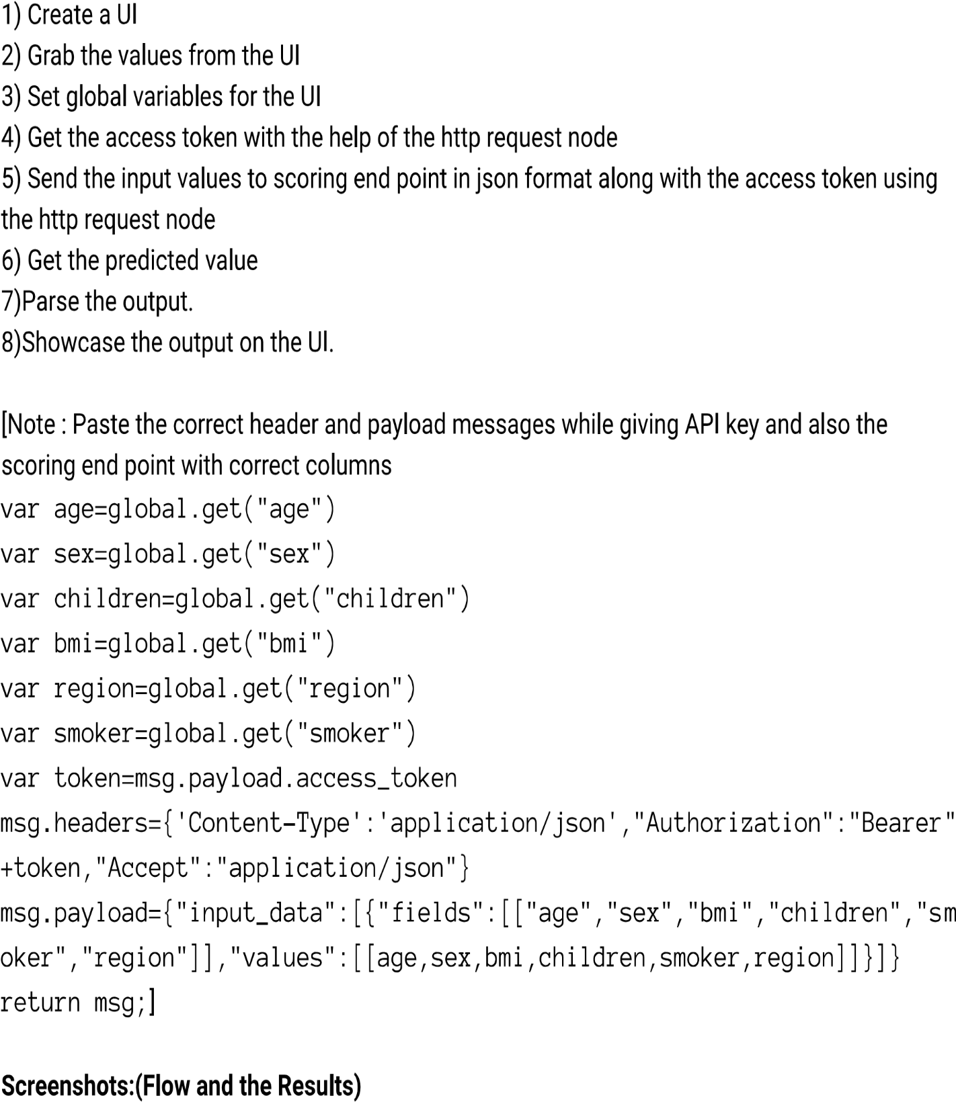

**Screenshot:**

**SOURCE CODE:**

<!doctype html>

<html lang="en">

<head>

<!-- Required meta tags -->

<meta charset="utf-8">

<!-- <meta name="viewport" content="width=device-width, initial-scale=1, shrink-to-fit=no"> -->

<title>AutoAI Insurance Prediction</title>

<link rel="stylesheet" href="https://cdnjs.cloudflare.com/ajax/libs/font-awesome/4.7.0/css/font-awesome.min.css">

<link rel="stylesheet" href="https://maxcdn.bootstrapcdn.com/bootstrap/4.4.1/css/bootstrap.min.css">

<script src="https://ajax.googleapis.com/ajax/libs/jquery/3.5.1/jquery.min.js"></script>

<script src="https://cdnjs.cloudflare.com/ajax/libs/popper.js/1.16.0/umd/popper.min.js"></script>

<script src="https://maxcdn.bootstrapcdn.com/bootstrap/4.4.1/js/bootstrap.min.js"></script>

<link rel="stylesheet" href="https://stackpath.bootstrapcdn.com/bootstrap/4.4.1/css/bootstrap.min.css"

integrity="sha384-Vkoo8x4CGsO3+Hhxv8T/Q5PaXtkKtu6ug5TOeNV6gBiFeWPGFN9MuhOf23Q9Ifjh" crossorigin="anonymous">

<meta name="viewport" content="width=device-width, initial-scale=1">

<link rel="stylesheet" href="https://cdnjs.cloudflare.com/ajax/libs/font-awesome/4.7.0/css/font-awesome.min.css">

<link rel="stylesheet" type="text/css" href="{{ url_for('static', filename='styles/styles.css') }}">

</head>

<body style="background-color: #d2deed">

<div class="topnav" id="myTopnav">

<a class="active" href="#"><i class="fa fa-fw fa-home"></i> Home</a>

<a href="#"><i class="fa fa-fw fa-envelope"></i> Contact</a>

<a href="https://github.com/IBM/predict-insurance-charges-with-ai"><i class="fa fa-info-circle"></i> About</a>

</div>

<center>

<div style="app-header">

<h2>Insurance Charges Estimator</h2>

<p>Estimation by IBM Watson Machine Learning and AutoAI.</p>

<p>Fill out the form to see an estimate.</p>

</div>

</center>

<form class="text-center" style="border-style: solid; color: #757575; margin-bottom:10px" method="POST" action="/predict">

<table width="100%">

<tbody>

<tr>

<td>

<div class="form-field">{{ form.age.label }} {{ form.age(size=20) }}</div>

</td>

</tr>

<tr>

<td>

<div class="form-field ">{{ form.sex.label }} {{ form.sex }}</div>

<!-- <div class="form-field ">{{ form.sex.label }} {{ form.sex }}</div>

<select id="equalification" class="">

<option id="selectHeader">--------- Select Gender --------------</option>

</td>

</tr>

<tr>

<td>

<div class="form-field ">{{ form.bmi.label }} {{ form.bmi }}</div>

</td>

</tr>

<tr>

<td>

<div class="form-field ">{{ form.children.label }} {{ form.children }}</div>

</td>

</tr>

<tr>

<td>

<div class="form-field ">{{ form.smoker.label }} {{ form.smoker }}</div>

</td>

</tr>

<tr>

<td>

<div class="form-field ">{{ form.region.label }} {{ form.region }}</div>

</td>

</tr>

</tbody>

</table>

<input id="submit" style="margin-bottom: 10px;" name="submit" type="submit" onclick="startSpinner()" value="Predict">

<br>

</form>

<div class="d-flex justify-content-center">

<div id="loader" style="color:black; display: none;" class="spinner-border"></div>

</div>

<div class="output-container">

<center>

<div id="output">

<h5 id="a">Predicted Insurance Charge: </h5>

<h3 id="b">{{ form.abc }}$$</h3>

</div>

</center>

</div>

<center>

<img src="static/diagram.png" alt="arch-diagram">

</center>

<script>

window.onload = function exampleFunction() {

// var output = document.getElementById("output");

// output.style.display = "none"

}

function startSpinner() {

var x = document.getElementById("loader");

x.style.display = "block";

var output = document.getElementById("output");

output.style.display = "none"

setTimeout(function () {

var y = document.getElementById("output");

var x = document.getElementById("loader");

var a = document.getElementById("a");

var b = document.getElementById("b");

x.style.display = "none";

y.style.display = "block"

a.style.display = "block"

b.style.display = "block"

}, 3000);

}

</script>

</body>

</html>

**App.py**:

from flask import Flask, url_for, render_template, redirect

from forms import PredictForm

from flask import request, sessions

import requests

from flask import json

from flask import jsonify

from flask import Request

from flask import Response

import urllib3

import json

# from flask_wtf import FlaskForm

app = Flask(__name__, instance_relative_config=False)

app.config["TEMPLATES_AUTO_RELOAD"] = True

app.secret_key = 'development key' #you will need a secret key

if __name__ == "__main__":

app.run(debug=True, host='0.0.0.0')

@app.route('/', methods=('GET', 'POST'))

def startApp():

form = PredictForm()

return render_template('index.html', form=form)

@app.route('/predict', methods=('GET', 'POST'))

def predict():

form = PredictForm()

if form.submit():

# NOTE: generate iam_token and retrieve ml_instance_id based on provided documentation

header = {'Content-Type': 'application/json', 'Authorization': 'Bearer '

+ "eyJraWQiOiIyMDIxMTAxODA4MTkiLCJhbGciOiJSUzI1NiJ9..HFJEQM-0ZPCry7CcVDNTFRmWmkJBBWOvfNBEE1F4Q8XA_a19N6jrx7Nrv29v_QZOyWcOTAWaEaeADQG0qjZ3SiDfvgCmFVHeQGqiTiKEcF9kBCc-PlRGkXdu4IPmzXLAi64nDXo1dmU_SityHkns39FaZnJd4njzDWi_WcGFlMxA2H7Wp4nDV6oZp5LUzriVT29Vr327ZMBYewvli7zeVdH-naZM1iqPCysaFirCcmhdx6YYoNozIuo850VSDFkE74nnu3Jbl8gLKOs7G8_PokA1tV1kiJISJcJcLJ2YmL0vZU_FerIez22IXeUenzKwtEstM9CC02dj4qrYuaByMA"}

if(form.bmi.data == None):

python_object = []

else:

python_object = [form.age.data, form.sex.data, float(form.bmi.data),

form.children.data, form.smoker.data, form.region.data]

#Transform python objects to Json

userInput = []

userInput.append(python_object)

# NOTE: manually define and pass the array(s) of values to be scored in the next line

payload_scoring = {"input_data": [{"fields": ["age", "sex", "bmi",

"children", "smoker", "region"], "values": userInput }]}

response_scoring = requests.post("https://us-south.ml.cloud.ibm.com/ml/v4/deployments/3baa72a2-8a2b-44e5-80de-b80db092d879/predictions?version=2020-09-01", json=payload_scoring, headers=header)

output = json.loads(response_scoring.text)

print(output)

for key in output:

ab = output[key]

for key in ab[0]:

bc = ab[0][key]

roundedCharge = round(bc[0][0],2)

form.abc = roundedCharge # this returns the response back to the front page

return render_template('index.html', form=form

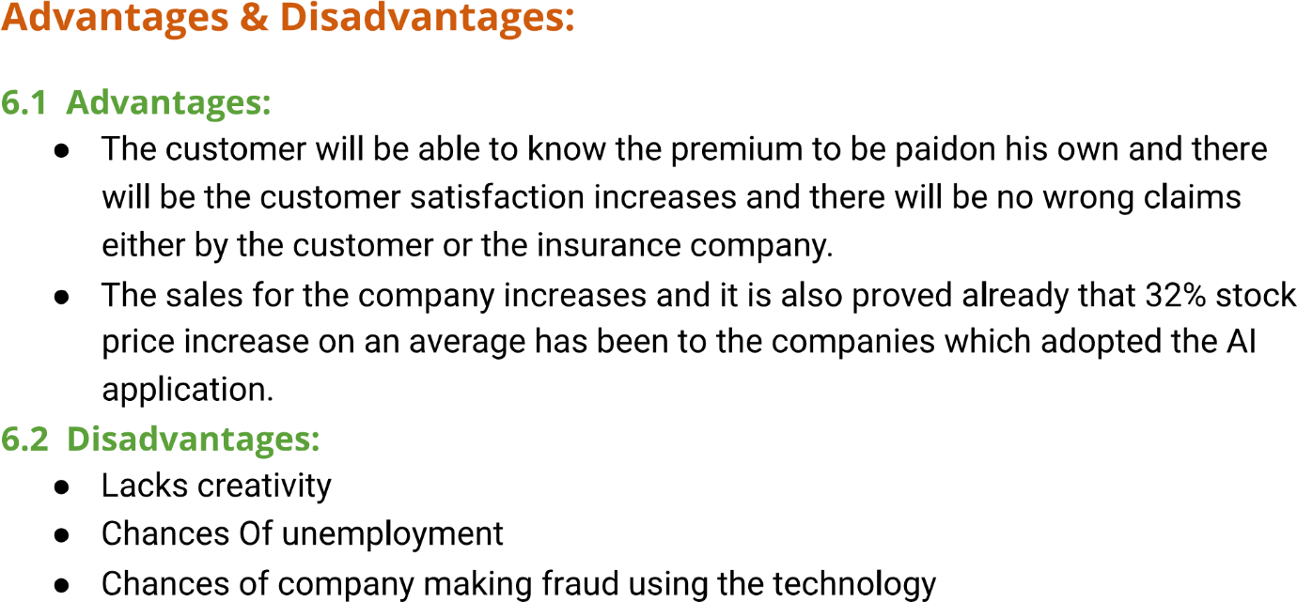

**ADVANTAGES AND DISADVANTAGES:**

**ADVANTAGES:**



**DISADVANTAGES:**

